**Northeastern University**

CS 5100 Foundations of Artificial Intelligence

**Homework and PA #3** [300 points]

***PART A: Theory and Algorithms*** *[100 points] * See PART B Programming Assignment on Page 3*

Please - clearly write your **full name** on the first page. Submit a single PDF file as your answer for Part A.

Please provide brief but complete explanations, using diagrams where necessary, and suitably using your own words. While presenting calculations and equations, explain the variables and answers in words.

**All questions** below are from **Khemani** book. (Study AIMA Norvig Ch. 3, 4, 5. + Khemani 3, 4, 5 and 8. )

Please refer to Khemani Book and answer the below questions:

1. Question #2 [15 Points] (at the very end of Ch 3)



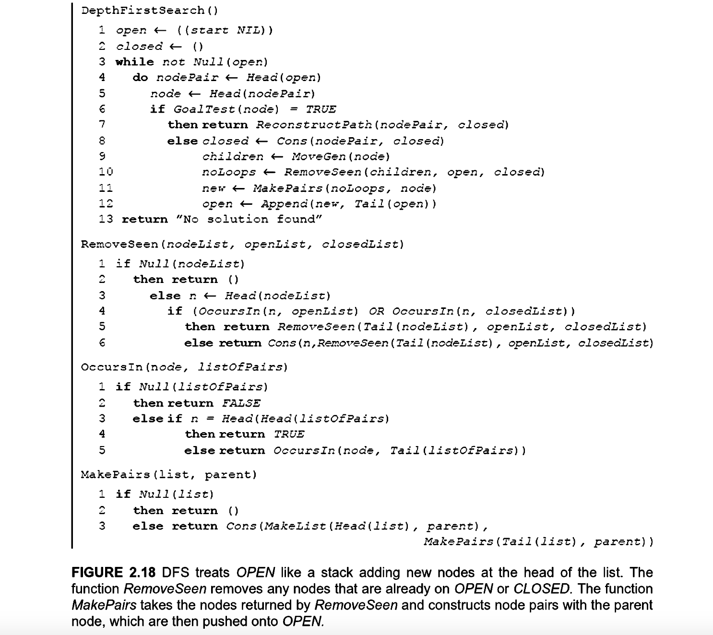

1. Question #2 [10 Points] (at the very end of Ch 4)

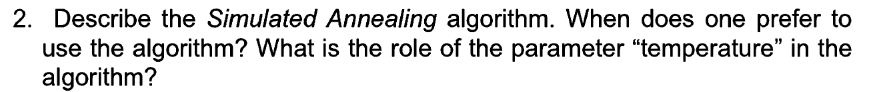

1. Question #3 [10 Points] (at the very end of Ch 4)

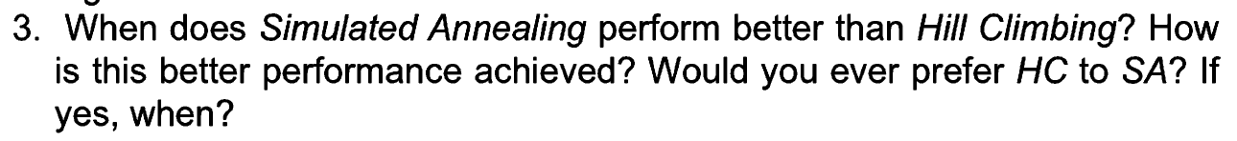

1. Question #5 [10 Points] (at the very end of Ch 4)

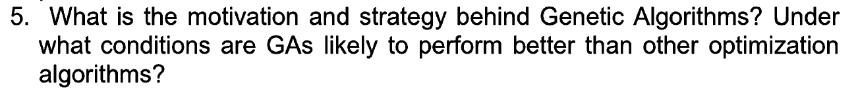

1. Question #1 [20 Points] (at the very end of Ch 5)

1. Question #2 [15 Points] (at the very end of Ch 5)

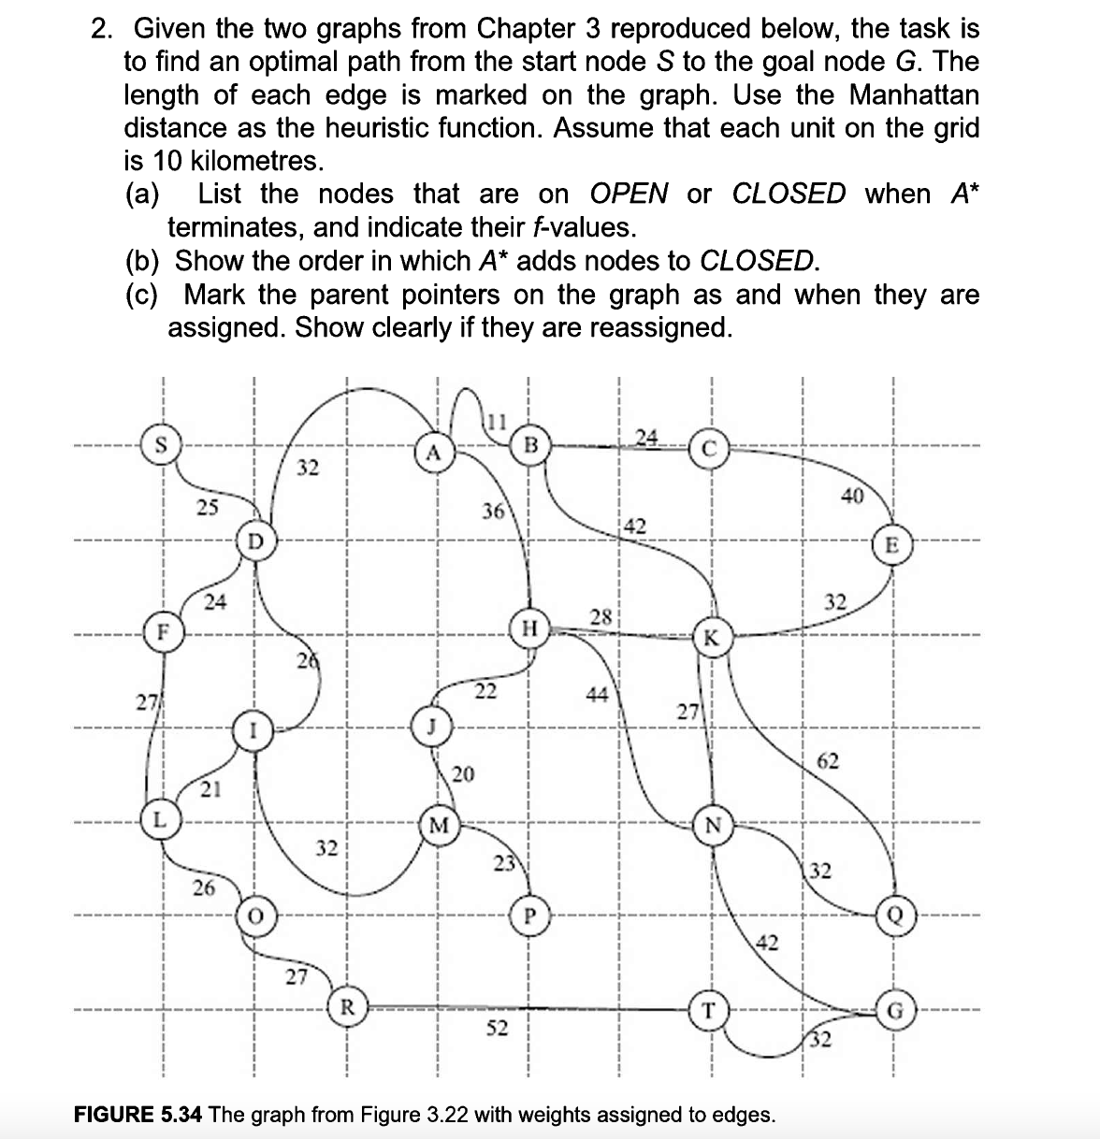

1. Question #14 [20 Points] (at the very end of Ch 8)

***PART B: Implementation – Programming Assignment (PA #3)*** *[200 points]*

See PA 3 as a separate attachment PA3 Hill Climbing.pdf.